Sensory Physiology
Name:
Date:

OBJECTIVES
- To review the basic anatomy of the eye, ears, and skin.
- To understand the basics of seeing, hearing, and touch.
- To learn how to test vision, hearing, and touch.
- To learn about abnormalities in vision, hearing, and touch.

INTRODUCTION
The main objective of this lab was to review the sense organs: visual system, auditory system, and somatosensory system. Watching the recorded lab video and reviewing all figures within given handout enabled us accomplish this.

BACKGROUND

Conventionally, there are five senses: sight, hearing, taste, smell and touch (visual, auditory, gustatory, olfactory and tactile senses, respectively). This is clearly an oversimplification. Additional sensory modalities include temperature, pain, vibration, joint position and proprioception.
‘
PROCEDURE
- Vision
Equipment

• Light • Black pen
• Pin or paperclip • Black item
• White paper • Red item

Protocols:

Vision-Convergence of gaze:

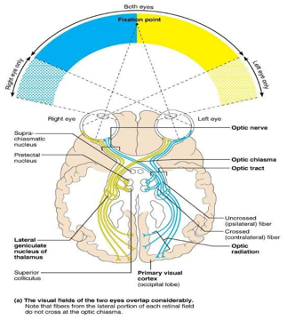
1. Binocular vision requires that the separate images in the right and left eyes be ‘fused’ to give a single view. Fusion of the images of an object is possible only if the images fall on corresponding parts of the right and left retinae. If they do not, a double view of the object results.

2. Held one arm outstretched, with the index finger upright and in line with some distant object (for example a clock on a far wall). Looked at the finger (keeping it in focus) but concentrating all attention on the distant object. Note that the distant object was seen doubled: there are two images, side by side. Covered the right eye. Note that the right image of the distant object disappeared. With both eyes opened, looked at the distant object. Note that the finger is seen doubled. Covered the right eye. Note that the left image of the finger disappeared. Asked a volunteer to look first at a distant object, and then at an object held close up (15 cm from the face). Note that the volunteer’s eyes are turned inwards when looking at a close object
Recorded observations in the section labeled “Data Notebook.”

Vision-Accommodation (focusing)

- The eye can accommodate (change focus) for far or near vision, by varying the shape of the lens.

- Covered one eye and hold a pin about 15 cm in front of the other eye, in line with some distant object. Looked at the distant object and note that the pin appeared blurred and dim: it is out of focus. Then looked at the pin. Note that the distant object became dim and indistinct. Note also that accommodation for the near object (the pin) was accompanied by a feeling of effort. Covered one eye and held the pin at arm’s length. While looking at the point of the pin, slowly brought it toward the face until it became blurred. The shortest distance at which the pin was kept in focus is the ‘near point’.
Recorded your observations in the section labeled “Sample Data & Data Analysis

Vision-Accommodation (focusing)
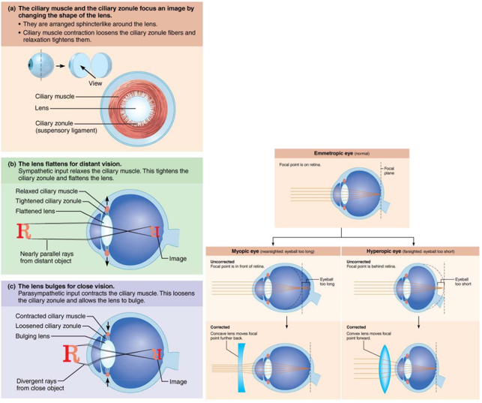
Vision-The blind spot

- The visual field for each eye includes a blind spot, representing the optic disc — a part of the retina with no photoreceptors.

- Obtained a pen that writes with black ink but has a white barrel. Alternatively, wrapping some white paper around the barrel of a black fiber-tipped pen, leaving only the black writing tip exposed. Marked a small cross on a piece of white paper. Closed the left eye and looked steadily at the cross, at a distance of about 25 cm. Moved the pen out (to the right) from the cross. At a certain distance the tip became invisible. Marked this place with a spot on the paper. Carried the pen further to the right, until it became visible again. Marked this place with another spot. Similarly, marked the upper and lower limits of the blind spot.
- Recorded observations in the section labeled “Data Notebook.”

Vision-Mechanical stimulation of the retina

- The eye has properties similar to those of a camera, in that the image formed on the retina is inverted. Light falling on the retina on one side of the eye gives a visual response in the opposite side of the visual field. Mechanical stimulation of the retina, by pressure on the eyeball, also gives a visual response that is inverted.

- Turned one’s gaze to the left and shut both eyes. Kept looking to the left. With a fingertip, pressed gently on the right side of the right eyeball, at the corner of the eye. Noted the visual effect. Sided a finger up and down and noted the direction of movement of the visual response. Turned one’s gaze to the right, and similarly press on the left side of the right eyeball, at the corner of the eye. Again, noted the visual effect.

- The main visual response to stimulation is a bright circle or disc, on the opposite side of the visual field from the site of stimulation. Stimulation of the retina on the right side of the eye gives a response on the left, and vice versa.
- Record the observations in the section labeled “Data Notebook.”

Vision-The positive after-image

- Retinal photoreceptors have a surprisingly long and slow response to light. A brief visual stimulus gives rise to a response that outlasts the stimulus long enough to give an after-image.

- Faced a bright scene, such as a sunlit window or a strongly illuminated bench top. Closed both eyes and covered them with hands. Waited for 30 seconds the removed the hands, and opened the eyes for the shortest possible time, then closed them again. Noted the afterimage i.e. Bright features of the scene remain visible for an appreciable time (a substantial fraction of a second).
- Record observations in the section labeled “Data Notebook.”

Vision-The negative after-image

- The sensitivity of retinal photoreceptors decreases gradually while they are being stimulated by light and increases while they are not. This adaptation to light and dark allows visual function over a very wide range of light intensities. It has the side effect of giving rise to negative after-images.

- Placed a black object on a piece of white paper then looked fixedly at the black object for 30 seconds. Shifted the gaze to a piece of plain white paper and noted the after-image of the black object. The image lasted for many seconds. The image was inverted in contrast (the black object gives a bright after-image), hence the name ‘negative after-image’. Repeated with a colored object and noted the color change in the after-image. For example, a red object gives a green after-image.

- Recorded observations in the section labeled “Data Notebook.”

Vision-Pupillary Light Reflex
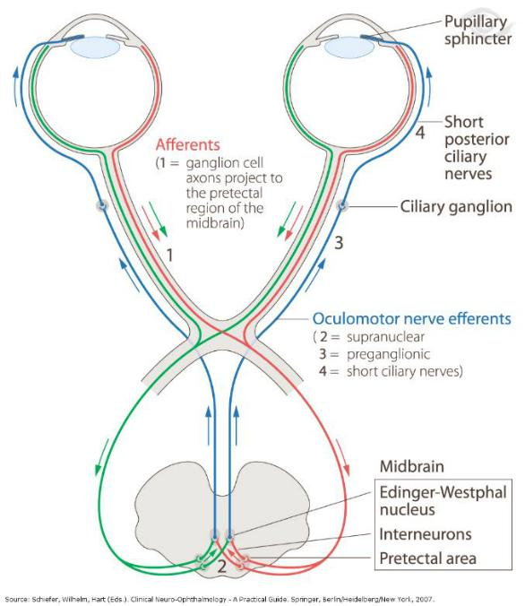

- Obtained a penlight. Had the patient stare keeping both eyes opened and had them look forward the entire experiment. Turned on the penlight and held it out to the right of the patient. Tested their right pupillary reflex first. Continuously looked at their RIGHT eye. Moved the light in front of their RIGHT eye until would see their RIGHT pupil constrict. Quickly moved the penlight away and allowed the pupil to dilate. Continuously looked at their LEFT eye. Moved the light in front of their RIGHT eye until would see their LEFT pupil constrict. Quickly moved the penlight away and allow the pupil to dilate. After testing their right pupillary reflex, tested their left pupillary light reflex by running steps ii-x and modify as needed.
- Recorded observations in the section labeled “Sample Data & Data Analysis

Somatosensory

Equipment

• Paperclip • ruler

- The density of tactile receptors in the skin differs greatly in different parts of the body.

- Took a metal paperclip and unfolded it. Bended it into a U shape, with the wire points about 10 mm apart. Touched the two points gently on the palm of a volunteer’s outstretched hand and ask if one point or two is felt. With a separation of 10 mm, the double stimulus from the two points was easily felt. Asked the volunteer to close both eyes. Bended the paperclip so as to bring the points closer together. By repeated trials with different point separations, found the smallest separation that the volunteer can distinguish as two points. Tested the truthfulness of the volunteer’s responses, from time to time, by turning the paperclip slightly, and pressing only one of the points down. Measured the separation of the points with a ruler. Repeated steps 3 and 4 with trials on different parts of the body (for example, a fingertip, the back of the hand and the back of the forearm).

- Recorded observations in the section labeled “Sample Data & Data Analysis”

Protocols:

Somatosensory-Two-point discrimination

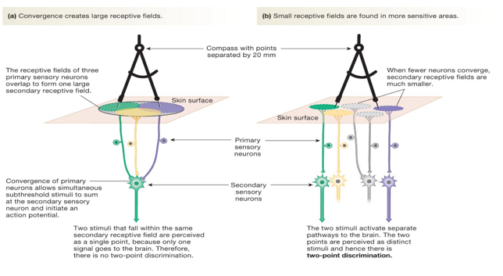
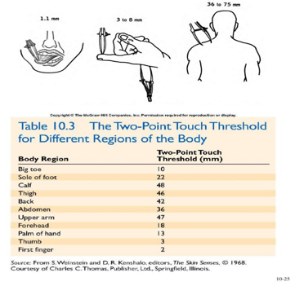
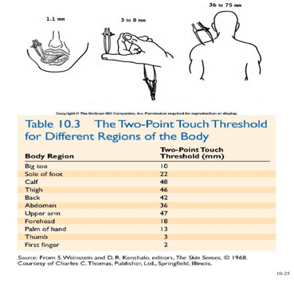

Somatosensory-A thermal illusion

- Many sensory systems show adaptation: a declining response to a continued steady stimulus. Temperature sensors in the skin adapt in this way, and so thermal sensations of warmth or cold are determined more by changes in temperature than by the temperature itself.

- Obtained three containers (small buckets or large beakers). Filled one container with hot, but not painfully hot, water. Filled another with cold water and fill the third with lukewarm water. Placed one hand in hot water and the other hand in cold water. Left them there for 30 seconds then placed both hands in the lukewarm water. Note any sensations.

- Recorded observations in the section labeled “Data Notebook.

Hearing

Equipment

- Turning fork set

- Rubber mallet

- Ear plugs

Protocols

Note: you will be unable to complete the following protocol at home. However, you must still understand the procedure and complete the corresponding section under “Sample Data & Data Analysis”

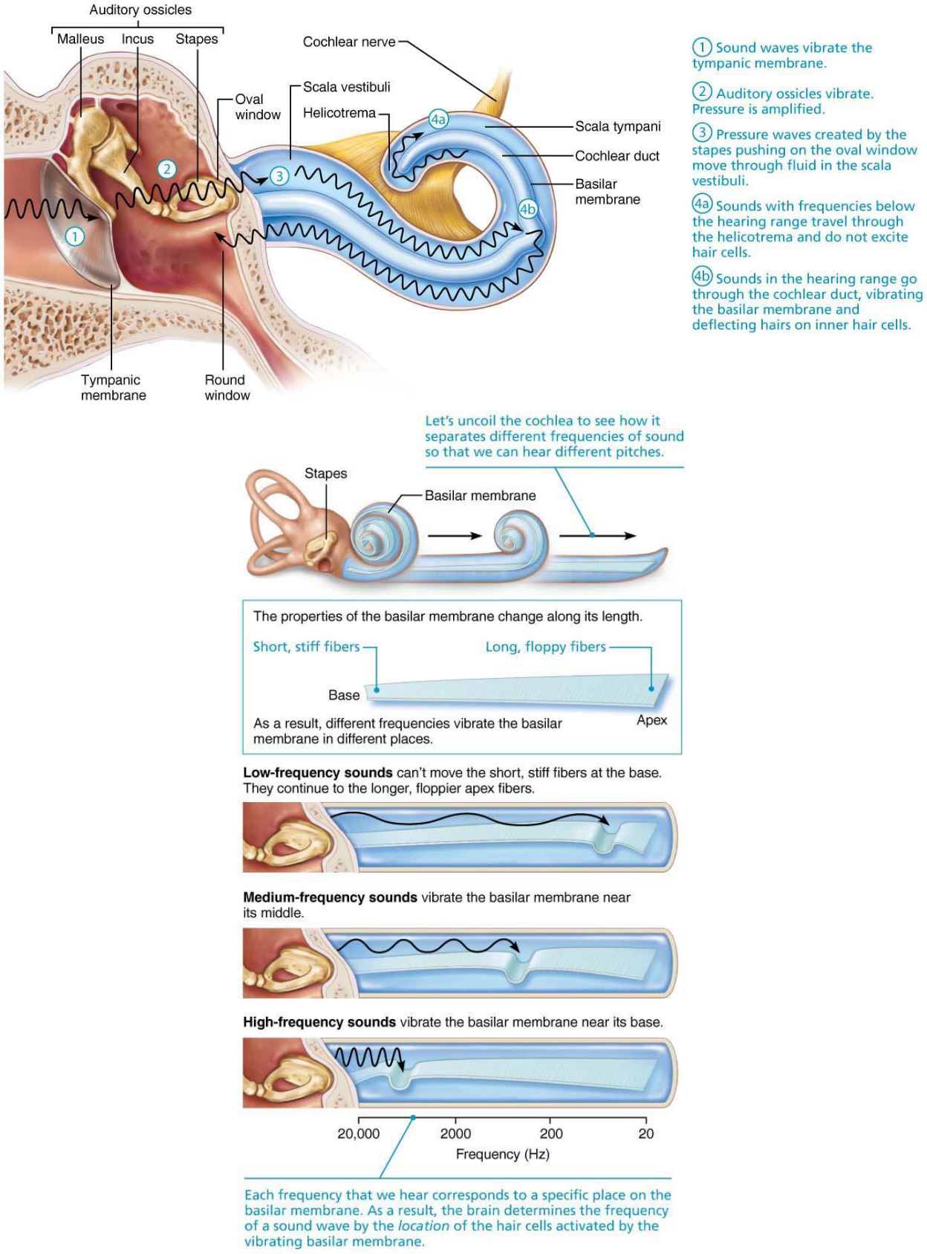
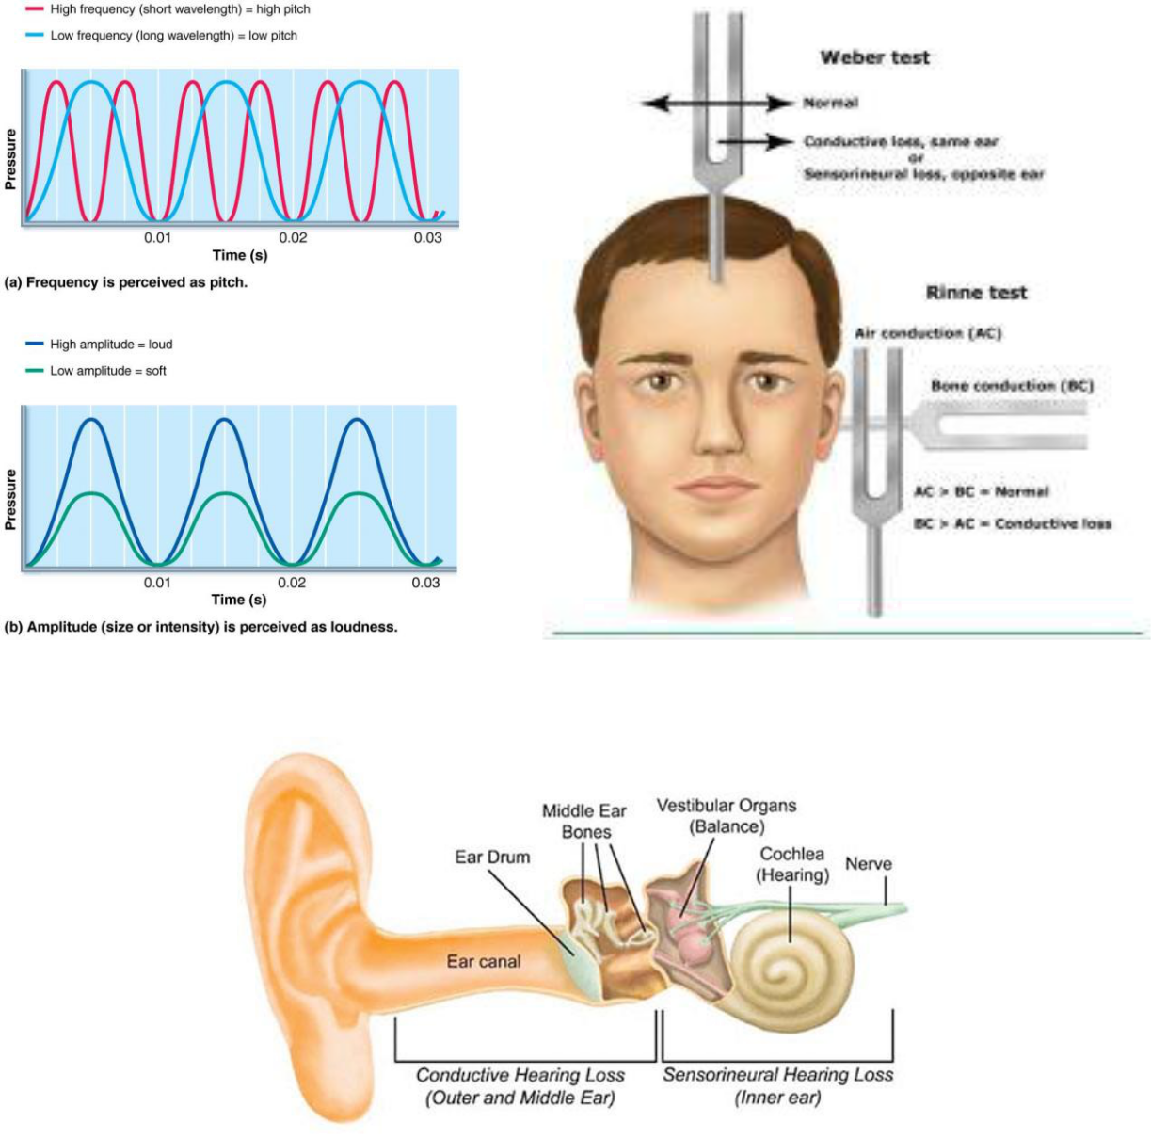

Preferred frequency for your patient:

- Have the patient sit in a chair and stand behind them.

- Use any 128Hz tuning fork and strike it behind them. Then use the 256Hz tuning fork and strike it behind them. Ask them which one they hear well.

- Use the one they hear best and then test another tuning fork (512, 1012, 2048Hz) to find out which tuning fork they hear best.

- Use the tuning fork that they hear best with and run all the following tests.

Weber Test (test for general deafness; non-specific).

- Strike the tuning fork and place the base of the handle at the top (middle) of the patient’s skull.

- Ask the patient if they hear the sound equally in both ears. Normally they should. Abnormal results happen when patients hear the sound louder on one side. Record you results.
Rinne Test (test for conduction deafness)

- You will test the RIGHT ear first.

- Tap the tuning fork and place the base of the handle on your patient’s right mastoid process. Hold it in this position until they indicate that they cannot hear the sound any longer.

- Quickly move the tuning fork near the right ear. Make sure the prongs of the tuning fork are parallel to the ear. Normally you should hear sound.

- Tap the tuning fork and place the prongs of the tuning fork near the right ear. Hold it in this position until they indicate that they cannot hear the sound any longer.

- Quickly move the base of the tuning fork onto the right mastoid process. Normally you should not hear sound.

Simulate Conduction Deafness

- Wear an earplug or place cotton in one ear.

- Run the Weber Test and record the results.

- Run the Rinne’s Test and record the results.

SAMPLE DATA & DATA ANALYSIS:

Vision

- Monocular and Binocular Field of View

- Label the vision disk using the following data:
  - Left eye ranges from 30-100 degrees

  - Right eye ranges from 60-110 degrees.

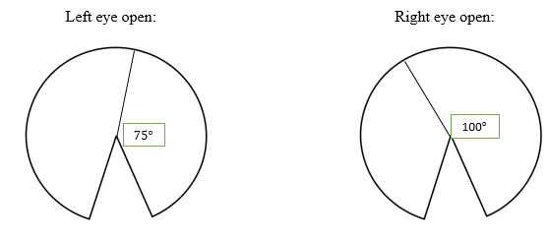

- Overlap your results from both tests. Color the monocular field of views and the binocular field of view different colors.
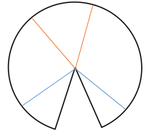

The orange color is monocular field of view
Which is at 75$°$ and 105$°$
The blue color is binocular field of view which is at 15$°$ and 165$°$

- Accommodation

- Do you wear glasses/contacts? If so, are you far (hyperopia) or near (myopia) sighted?

I do not wear glasses/contacts but my friend does, he is hyperopia, he can distant objects clearly but nearby objects appear blurred.

- Right eye distance: _10 cm
- Left eye distance: __10cm

- Pupillary light reflex

  - Did your patient/you have a normal response? YES

- What happened to the RIGHT pupil when you shined the light in the RIGHT eye?

The right pupil constricts on shining light to the right eye because the light caused the muscles of the pupil to close.

- What happened to the LEFT pupil when you shined the light in the RIGHT eye?

The left pupil constricted slightly, because part of the optical nerve from the right pupil crossed over and coupled with the muscles controlling the pupil of the left eye.

- What happened to the LEFT pupil when you shined the light in the LEFT eye?

The left pupil did no constrict as expected, it remained normal. This could be because the efferent nerve signals cannot pass from midbrain through the CN II to the left pupillary muscles. The muscles would not close and so the pupil could not constrict.

- What happened to the RIGHT pupil when you shined the light in the LEFT eye?

The right pupil constricted. This would be because the afferent nerve signals on the left pupil and the one on the right pupil are interconnected and the reflex is transferred from the left nerve signals to the right pupillary nerve signals.

- If possible, draw the pathway showing a right CNII lesion. What would be the results if you ran the pupillary light reflex test?

Light shined in one eye causes both eyes to constrict. Lesions of CNII produces an afferent pupillary defect from the light shined on the side of the eye with CNII lesion which causes unresponsiveness to pupillary light reflection both sides. On shining light in the unaffected eye, both pupils constrict.

- If possible, draw the pathway showing a right CNIII lesion. What would be the results if you ran the pupillary light reflex test?

Lesion of CNIII causes unresponsive pupillary constriction on the affected side (the side with CNIII). On shining light to either of the two pupils, the affected pupil will only constrict while the unaffected pupil remains fixed and dilated.

Hearing and Equilibrium

- Normal-Preferred frequency: ______2048Hz__________

- Weber Test Results:______516Hz___________

- Rinne Test Results: _______256Hz_________

- Simulation-Conduction Deafness

  - Weber Test Results:______516Hz_________

o Rinne Test Results: ______256Hz___________

- Compare and contrast conduction deafness and sensorineural deafness. Which type of hearing impairment would benefit from using a cochlear implant?

Conductive deafness means that the sound is not reaching the inner ear because of obstruction or trauma while sensorineural deafness means that there is a problem with the inner ear or the auditory nerve hence sound cannot be delivered to the brain.
Cochlear implant is good for correcting sensorineural deafness because it stimulates the cochlear nerve hence providing a person with sensorineural deafness a modified sense of sound.

Touch

- Two-point discrimination test

- What is the threshold for the tip of the finger? ___2mm to 8mm_____

- What is the threshold for the back of the hand? ____70mm_______
- What is the threshold for the back of the neck? ____10mm to 45mm______

- Which site is more sensitive?____ Fingertip___________
- Which site is least sensitive? __Back of hand___________ Explain.

The most sensitive part of a body is the one with smaller threshold because they have more nerve endings while the least sensitive part is the one with the highest threshold because they have the least nerve endings.

DATA NOTEBOOK:

Record observations for each exercise in the spaces below.

Exercise 1: Convergence of gaze

On looking at the finger and concentrating all attention on the distant object, the distant object appeared doubled, there were two images side by side. On covering the righty, the right image of the distant object disappeared. With both eyes opened and looking at the distant object but concentrating on the finger, the finger appeared doubled and on covering the right eye, the left image of the finger disappeared.
The volunteer’s eyes are turned inwards when looking at a close object on looking first at a distant object, and then at an object held close up.

Exercise 3: The blind spot

On closing the left eye and looking steadily at the marked cross on a piece of white paper, at some point the cross started disappearing. As I moved the pen out from the cross, at about 20cm, the tip of the pen became invisible.

Exercise 4: Mechanical stimulation of the retina

With a fingertip, press gently on the right side of the right eyeball, at the corner of the eye, response was felt from the left and press on the left side of the right eyeball, at the corner of the eye, response was felt from the right. The main visual response to stimulation is a bright circle or disc, on the opposite side of the visual field from the site of stimulation. Stimulation of the retina on the right side of the eye gives a response on the left, and vice versa

Exercise 5: The positive after-image

On closing he eyes for 30secs then opening them for about 30secs and then closing them again, bright features of the scene remained visible for about 2 secs. This would be because the original image stimulated nerve impulses which continued for a small window after closing the eyes because cells in the retina takes some time to respond and cease from light.

Exercise 6: The negative after-image

On shifting the gaze to a piece of plain white paper, the black image turned bluish and was inverted as well. This effect is as result of negative afterimages whereby some retina cells do not respond to the current stimulation since they became desensitized by glazing at a previous stimulus. The sensitivity of photoreceptors decreases gradually while they are being stimulated by light and increases while they are not.

Exercise 9: A thermal illusion

The warm water felt extremely cold to the hand that was originally placed in hot water while the warm water felt warmer to the hand that was placed in the cold water. Thermal illusion occurred in this scenario whereby, the skin sensory system declined response to a continued steady stimulus.

